|  |
| --- |
| **CHAPTER** 4 |

**Data types in C**

Data type is used to define a variables means in this container which type of data you want to store and also define the size and type of data according to data type.

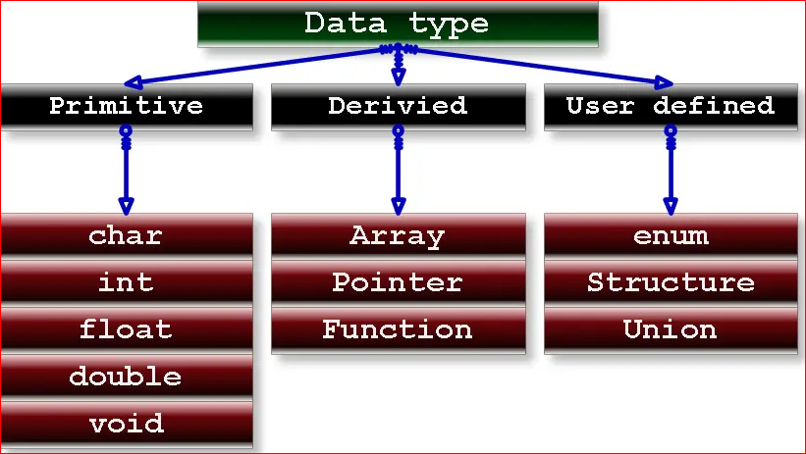

**Data types in C++**

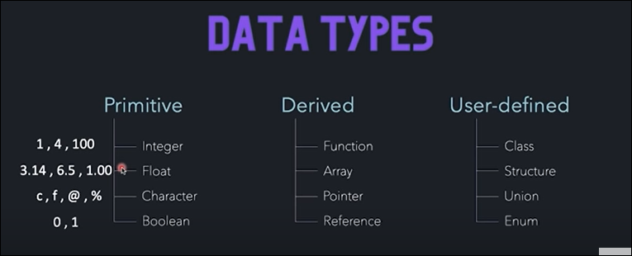

**Format Specifier**

**Format specifiers is just use to inform the compiler what type of data the variable is storing.**

|  |  |  |
| --- | --- | --- |
| Format Specifier | Data Type | Size |
| %d or %i | int | **2 or 4 bytes** |
| %f | Float | **4 bytes** |
| %lf | Double | **8 bytes** |
| %c | char | **1 bytes** |
| %s | string |  |
|  |  |  |

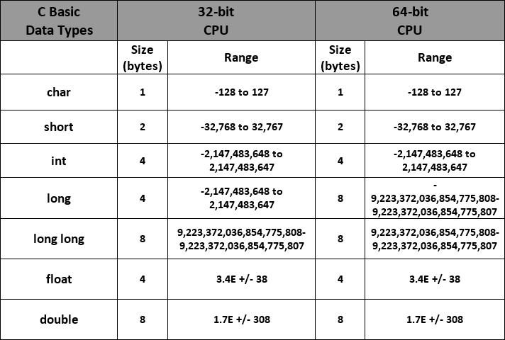

# Integer contain 4 byte space in memory and all byte have same size.

1 block = 1 byte = 8 bit

In 32 bit operating system has 32 block

|  |  |  |  |  |  |  |  |  |  |  |  |  |  |  |  |  |  |  |  |  |  |  |  |  |  |  |  |  |  |  |  |
| --- | --- | --- | --- | --- | --- | --- | --- | --- | --- | --- | --- | --- | --- | --- | --- | --- | --- | --- | --- | --- | --- | --- | --- | --- | --- | --- | --- | --- | --- | --- | --- |
| 1 | 2 | 3 | 4 |  |  |  |  |  |  |  |  |  |  |  |  |  |  |  |  |  |  |  |  |  |  |  |  |  |  |  | 32 |

4-byte integer contain 4 byte

**Range of integer value** 

Range of integer value is 0 to 2 ^32 -1

memory

Integer- 4 byte

Character- 1 byte

**Example of finding size of data type.**

#include<stdio.h>

int main()

{

    int a;

    float f;

    char c;

    printf("size of int %d",sizeof(a));

    printf("\n size of chaar %d",sizeof(c));

    printf("\n size of float %d",sizeof(f));

*//method 2 find the size of variable without using sizeof() operators.*

    printf("\n size of int %d",(char*)(&x+1)-(char*)&x);

     return 0;

}

1. **Data type declaration instruction.**

* We can’t use more then one data type in single line.

Int a, int b;

* First word must be data type when we declare the data type in a program.

INTEGER

An integer is a whole number(not a fractional number).that can be positive, negative or zero.

Note

* An integer constant must have at least one digit.
* It must not have a decimal point.
* It can be either positive or negative.
* If no sign precedes an integer constant, it is assumed to be positive
* No commas or blanks are allowed within an integer constant.
* The allowable range for integer constant is -32768 to 32767 for Turbo c or turbo c++ (depends upon the compilers).

Example:

23, -23 , 0, +45 etc.

REAL/FLOAT

The numbers containing fractional parts like 99.25 are called real or floating points constant.

Note

* An real constant must have at least one digit.
* It must have a decimal point.
* It can be either positive or negative.
* If no sign precedes an real constant, it is assumed to be positive.
* No commas or blanks are allowed within an real constant.

Example:

23.56, -23.56, -0.065, 2.0 etc.

Size of float is 4 byte

Eg . 4.322, 5.16 (we can store up to 7 decimal digit)

If we want to store more the 7 decimal digit we use double, size of double is 8 byte and we can store up to 15 decimal digits.

**float vs. double**

The **precision** of a floating point value indicates how many digits the value can have after the decimal point. The precision of float is only six or seven decimal digits, while double variables have a precision of about 15 digits. Therefore it is safer to use double for most calculations.

**A floating point number can also be a scientific number with an "e" to indicate the power of 10:**

 35e3= 35* 10^3  
 12E4= 12* 10^4

**CHARACTER**

It simply contains a single character enclosed within ' and ' (a pair of single quote). It is to be noted that the character '**8**' is not the same as **8**.

Size of character is 1 byte.

Character constants store in memory with the help of ASCII values (American Standard Code for Information Interchange).

Note

* A character constant is a single alphabet, a single digit or a

single special symbol enclosed within single inverted commas.

* The maximum length of a character constant can be 1 character.

Example:

'X', '5', ';', ’A’, ‘a’, ‘space’, ‘2’, ‘=’.

* a, b, c are not character constant because character constant always

written in single code( ‘ ’ ).

* ‘-3’, ‘3.4’, ‘+4’, ‘lazy’, these are not character constant b/c character

constant contain only one char, num or operator etc.

Example:

‘ - 3 ’

.

Operator number

Here contain two value so that is not possible in character constant.

**Boolean data type in C++**

A boolean data type is declared with the bool keyword and can only take the values true or false. When the value is returned, true = 1 and false = 0.

**STRING CONSTANT**

These are a sequence of characters enclosed in double quotes, and they may include letters, digits, special characters, and blank spaces. It is again to be noted that "**G**" and '**G**' are different - because "G" represents a string as it is enclosed within a pair of double quotes whereas 'G' represents a single character.

Example:

"Hello!", "2015", "2+1" “a” string, ‘a’ character constant.

